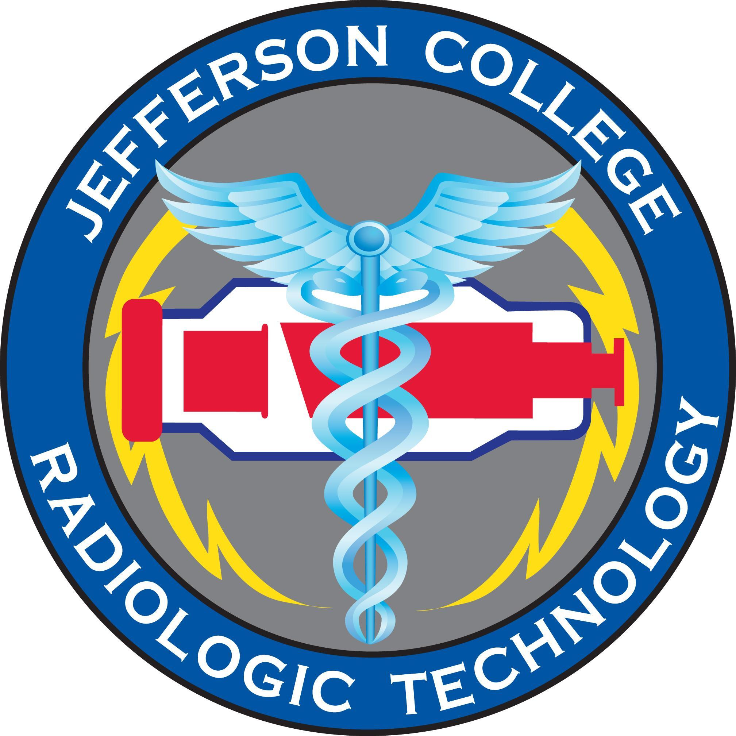

|  |  |
| --- | --- |
|  |  |
|  |  |

**Radiologic**

**Technology**

**Program**

|  |
| --- |
| **CLINICAL HANDBOOK**  Additional Policies in the Jefferson College Course Catalog & Student Handbook. *It is the policy of Jefferson College that no person shall, on the basis of age, ancestry, color, creed, disability, genetic information, marital status, national origin, race, religion, sex, sexual orientation, or veteran status, be subject to discrimination in employment or in admission to any educational program or activity of the College. In compliance with Federal Rules and regulations, Jefferson College has adopted a procedure for resolving complaints of discrimination.*  *.*  Jefferson College  1000 Viking Drive, Hillsboro, Missouri 63050  Revised 7/10/23 SW/RD |

**Table of Contents**

**Clinical Objectives 3**

**Five Steps to Clinical Competency 3**

**Clinical Education Supervision 4**

**Performance Competency Evaluations 4**

**Simulations 5**

**Clinical Grades 5**

**Clinical Attendance 6**

**Absence/Tardy** **6**

**Clinical Attire 7**

**Physical Adornment 8**

**Personal Appearance 8**

**Professionalism in the Clinical Area 9**

**Smoke-Free/ Tobacco Free Policy 9**

**Use of Phones and Smart Watches and Other Devices 9**

**Clinical Preparedness 9**

**Clinical Assignments 9**

**Clinical Education Sites 10**

**Regulations Governing Clinical Assignment** **11**

**Personal Dosimeters 1****2**

**Radiation Safety & Monitoring 12**

**Lead Markers 12**

**Technique Book 12**

**Clocking In/Out at the Clinical Sites 1****3**

**Student Positioning and Radiation Exposure 13**

**Pregnancy Policy 1****4**

**Patient Records and Confidentiality 1****5**

**Jefferson College Procedures Competency List 1****6-19**

**Radiology Exam Log 20**

## Clinical Objectives

Clinical rotations provide the student with the opportunity to practice skills and theory taught in the classroom. The Five Steps to Clinical Competency allows the student to progress in competency exams, while practicing patient care and professionalism. The following are the clinical objectives:

* + Demonstrate professional behavior.
  + Provide basic patient care and comfort and respond correctly to emergency situations.
  + Follow appropriate infection control guidelines.
  + Provide appropriate patient education and maintain patient and department records.
  + Practice radiation protection for patients, self, and other health care workers.
  + Operate medical imaging equipment and accessory devices.
  + Recognize equipment malfunctions and report them to the proper personnel.
  + Demonstrate knowledge and skills relating to verbal, nonverbal, and written medical communication in

patient care intervention and professional relationships.

* + Support the profession’s code of ethics.
  + Comply with the radiologic technologist’s scope of practice.
  + Achieve clinical competency by progressing through the five steps.
  + Reinforce learned skills by continuing to perform examinations after achieving competency.

## Five Steps to Clinical Competency

The following steps must be taken, in order, for each competency exam. After competency is achieved, the student may perform the procedure under indirect supervision. Regardless of the level of competency achieved, students must perform all repeat radiographs in the presence of a registered technologist.

**Step 1:** The examination is introduced in Radiographic Positioning class. The student will participate in guided discussion, demonstration, reading assignments, radiographic anatomy review and positioning practice.

**Step 2:** In the classroom the student must score 86% or above on a written examination covering the assigned objectives. The scores for these examinations are applied to the Radiographic Positioning class grade. If a student fails the Step 2 exam (below 86%), it is the student’s responsibility to contact the Positioning course instructor for another testing date. Re-testing will be at the instructor’s convenience and may be outside of regular class hours.

**Step 3:** In the laboratory, under the direct supervision of the Positioning instructor, the student will correctly position the examination according to a Lab Competency Test. The student must score 86% or above on the Lab Competency Test for satisfactory completion of Step 3. The scores for these examinations are applied to the Radiographic Positioning class grade. If a student fails the Step 3 Lab Competency Test (below 86%), it is the student’s responsibility to contact the Positioning instructor for another testing date. Re-testing will be at the instructor’s convenience and may be outside of regular class hours.

**Step 4:** In the clinical area, under direct supervision of a **registered technologist**, the student will correctly perform the examination on a patient. Three Step 4 competencies are required to progress to Step 5 on all mandatory examinations. Step 4 competency requires active performance of the exam but may utilize assistance from the technologist. The student must perform at least two of these exams and may not record more than one observation exam during the “experience recorded” portion of the competency. The student will ask the supervising technologist to evaluate their exam performance prior to beginning the exam.

**Step 5:** Clinical competency evaluation. Under the direct supervision of the Clinical Instructor, registered technologist or Jefferson College faculty, the student will correctly perform the examination according to the clinical competency evaluation. A score of 86% or better is necessary to achieve clinical competency. Competency scores for these exams apply to the Clinical Education grade. Step 5 competency requires independent performance of the exam.

**Clinical Education Supervision**

Until a student achieves and documents clinical competency in any given procedure, all clinical assignments shall be carried out under the direct supervision of a registered radiographer. Upon completion of the Five Steps to Clinical Competency students may perform radiographic examinations with indirect supervision. **Regardless of the level of competency achieved, students must perform all repeat radiographs in the presence of a registered radiographer.**

In providing **direct supervision**, the registered radiographer shall:

Review the request for the examination in relation to the student’s achievement.

Evaluate the condition of the patient in relation to the student’s knowledge.

Be present in the room during the examination.

Review and approve the radiographs before they are submitted to the radiologist.

In providing **indirect supervision**, the registered radiographer shall:

Be present in a room adjacent to the room where the procedure is being performed.

Review and approve the radiographs before they are submitted to the radiologist.

Be present in the room for all repeat radiographs.

As a student, it is your responsibility to be sure these expectations are met. Prior to completing competency on each exam, students are required to have direct supervision. This means a technologist/clinical instructor must be in the room when a student “performs and comps” on all exams. Once competency on an exam has been attained the technologist may be in an adjacent room, which places the student in the indirect supervision category.

If a student ever has a problem at a clinical site finding a technologist that is available to provide direct or indirect supervision, it is the student’s responsibility to inform the patient that there will be a short wait until a technologist becomes available. **Never complete an exam without the appropriate supervision.**

If a technologist has any issues with this requirement or is not willing to supply the supervision the student knows is required, please contact the clinical instructor, the clinical coordinator, or program director immediately.

## Performance Competency Evaluations

There are core competencies all individuals must demonstrate to establish eligibility for ARRT certification. The requirements listed are the minimum core clinical competencies necessary to establish eligibility for participation in the ARRT Radiography Certification Examination. ARRT encourages individuals to obtain education and experience beyond these core requirements.

Over the course of the semester, the student is expected to complete the Five Steps to Clinical Competency for a specific number of exams (see Performance Competency Evaluations). Students must demonstrate competency on all **37 of the mandatory** Radiologic Procedures. Competency demonstration should incorporate patient-specific variations such as age and pathology. Students must demonstrate competency in **15 of the 34** **elective** Radiologic Procedures.

A specified minimum number of performance objectives must be completed by the end of each semester (see schedule below). Failure to complete minimum performance requirements will result in a 10% reduction from the clinical grade and a grade of zero for each competency they are missing. Students are not allowed to simulate exams to compensate for the number of exams required for the semester. If a student has not completed the specified number of procedures for the previous and current semester, for two consecutive semesters, the student will be required to present to the Review Board to determine continuance in the Program.

At any time, the student feels confident, prepared, and has achieved the appropriate level of competency, the student may request a competency evaluation from the clinical coordinator or instructor. Students completing all competencies for the current semester may begin work on competencies for the following semester.

## Simulations

In the event a student cannot perform all required clinical competencies during the semester, they are not allowed to simulate exams to make up for missing exams. Only at the end of the Program will simulations be accepted in place of patient performed competencies. In addition, no more than 8 simulations are accepted by ARRT. Simulations will be accepted for Program completion only and will not be used to figure final semester grade. See semester grading in previous section titled “Performance Competency Evaluation.”

ARRT Requirements for simulation:

The ARRT requirements specify that certain clinical procedures may be simulated as designated in the specific requirements below. Simulations must meet the following criteria:

* The candidate must simulate the procedure on another person with the same level of cognitive, psychomotor, and affective skills required for performing the procedure on a patient.
* The program director or clinical coordinator must be confident that the skills required to competently perform the simulated procedure will transfer to the clinical setting, and, if applicable, the candidate must evaluate related images.

|  |  |
| --- | --- |
| **Semester** | **Total** |
| 1st Semester (Spring) | 8 |
| 2nd Semester (Summer/June) | 7 |
| 3rd Semester (Summer/July) | 7 |
| 4th Semester (Fall) | 15 |
| 5th Semester (Spring) | 15 |
| Totals | 52 |

## 

## Clinical Grades

Clinical grades are based upon the following factors: competency sheets, clinical performance evaluations, attendance, and deductions outlined in the handbook. The minimum clinical grade to pass is 86%.

1. Clinical competencies are worth 100 points each. Clinical competencies for the semester are averaged and counted as 100 points possible for the semester.
2. Students’ behavior at the clinical sites will be evaluated on a continuing basis. The evaluation is a portion of the student’s clinical grade. The scores for all rotations in a semester are averaged, and count as 100 points possible for the semester.

Example:

A. Sally Student has four competencies for semester one:

Chest 95%

Hand 98%

Abdomen 94%

Wrist 100%

These competencies average 97%.

B. Sally’s clinical performance evaluations for semester one:

100%

96%

98%

These performance evaluations average 98%.

C. Calculation of Sally’s clinical grade:

97 – average of competencies

93 – average of performance evaluations

190 – total points – 5 deductions = 185 out of 200 points possible = 93%

D. Deductions from the clinical grade will be taken for various reasons outlined in the handbook.

**Radiologic Technology Program Grading Scale:**

A=92-100%

B= 86-91.9%

C=80-85.9%

D=70-79.9%

F=69.9% and Below

Clinical grades are weighted 50% competency exams and 50% for evaluations.

## Clinical Attendance

Students are eligible for 10 days /80 hours of clinical absenteeism. This time can be used, as necessary, by the student over the life of the program. When the student reaches 5 days, the student will lose a percentage point per day missed until they have reached 10 days. Percentage points will be taken off the overall semester grade. When the student reaches 10 days of absenteeism the student will be placed on attendance probation. Excessive absenteeism, anything over 10 days, will be required to appear before the Review Board, for a hearing, to determine continuance in the Program. **Make-up time is not allowed.**

If the student has accumulated 5 tardies, they will lose one percentage point of personal time per tardy until they have reached 10. Percentage points will be taken off the overall semester grade. When the student reaches 10 tardies, the student will be placed on attendance probation. Excessive absenteeism, anything over 10 tardies, will be required to appear before the Review Board, for a hearing, to determine continuance in the Program.

**It is required that students notify the Clinical Coordinator and Clinical Instructor as early as possible prior to each absence.** The student must call the clinical site and email the Clinical Coordinator at the college if they are going to be more than 5 minutes late. Should the institutions not be notified, an additional percentage point will be deducted from the clinical grade. Should a student notify the clinical site and college that he/she will be late and then decide not to attend that day for half of the day or the whole day, the student must again notify the institutions of this decision. Should the institutions not be notified, a percentage point will be deducted from the clinical grade. If a student leaves the clinical site for any reason, the appropriate Clinical Instructor and the college must be notified. Failure to follow this policy will result in a percentage point deduction from the clinical grade.

## Absence/Tardy

1 -15 minutes = tardy

16 minutes and above = time will be subtracted rounded to the nearest hour.

**Any absence, without notification may be cause for dismissal.** Two days’ absence without notification or prior approval may result in automatic dismissal from the program.

## Clinical Attire

Professional attire instills confidence in the patients and promotes a positive image of the care received. Radiologic Technology students are required to wear the assigned clinical uniform for their clinical assignments. Students are allowed to wear hospital scrubs only when the student is on the OR/Portable rotation. Scrubs are hospital property and will not be worn into or out of any clinical site. Pants are not to be rolled up or tucked into socks. Uniforms, including shoes, should be clean, wrinkle free and neat. Personal dosimeter, school patches and name tags are to be worn when wearing scrubs. Watches may be worn, however, if the student is wearing a smart watch, it must be on airplane mode. Certain clinical sites do not allow smart watches at all, adhere to those facility policies. Failure to comply with this policy will result in a one percentage point deduction from the student’s grade for each occurrence.

**Uniforms**

Uniforms are to be worn at designated times only. They must be clean, wrinkle free, neat and in good repair.

* The uniform will consist of:
* Scrub top and pant in designated color with program patch sewn on left sleeve.
* White lab coat or designated color per affiliation site dress code with program patch sewn on left sleeve – clean and pressed. No hoodies/t-shirt or sweatshirt material can be worn over scrubs.
* A plain black, blue, or white t-shirt or long sleeve t-shirt can be worn underneath uniform.
* Mostly white or black shoes (clean and in good repair). Heels must be covered so they do not slide out. If any questions on shoes, get permission from Clinical Coordinator
* ID Badge must be always worn while in the clinical areas with name visible.
  + - Jefferson College Student ID
    - A hospital badge (if the hospital requires, the hospital will provide for the student)
  + Radiation monitors must be worn, always, in the clinical area.
  + Technique book
  + Right and Left Markers identified with the student’s initials.
  + Ink pen
  + Clinical competency binder

The Clinical Coordinator, Clinical Instructor and/or Radiology Director has the right to send any student home due to inappropriate dress. Uniforms must be approved by the Clinical Coordinator prior to wearing them to the clinical site.

The above items should accompany the student to clinical rotation every day. If a student is missing any part of the above list, the student will be considered unprepared for clinical. Any student unprepared for clinical may not be allowed to participate in the days clinical and the day will be treated as an absence from clinical.

## Physical Adornment

While the Radiologic Technology faculty recognizes the student’s right to express themselves in their jewelry and other forms of body art. Such expression of individuality is inappropriate in the clinical setting, where the patient population is generally of an older generation, which may find such things offensive. The following are considered inappropriate in the clinical setting:

1. Visible tattoos
2. Hair of an unnatural color
3. Piercing at any location other than the ear (including the tongue)
4. Jewelry 4. limited to post earrings, a watch and one ring (If the facility has a smart watch policy, It must be followed)
5. Unnatural make-up (example: black lipstick)
6. Perfume, cologne, or heavily scented lotions
7. Artificial nails
8. Gum or candy in the mouth while performing patient care/exams.

All visible tattoos must be covered during clinical rotations. Pierced jewelry other than a double stud earring per ear is to be removed prior to entering the clinical site. Perfumes and colognes can cause allergic reactions and/or nausea in the patients therefore fragrances should be avoided. Artificial nails may allow for the trapping of microbials when entering patient contact situations.

**Personal Appearance**

As a radiologic technology student, you represent Jefferson College, classmates, and radiology as a profession, to the public, patients and their visitors. A student’s conduct, dress, and appearance are important. Cleanliness and neatness are necessary because of the nature of our work. The following requirements have been established:

* Good daily personal hygiene in both classroom/clinical includes daily bath, use of effective deodorant and good oral hygiene (persistent halitosis and/or body odor, for whatever reason will be cause for dismissal).
* Cologne, perfume, or after-shave lotion should be avoided.
* Hair must be clean, simply styled, well-groomed and off the collar while in uniform. If hair is long enough to fall into the student’s eyes, the front must be secured away from the face. If the back is long enough to fall past the shoulders all the hair must secured away from the face. Large decorative barrettes, large colored bows, and ribbons are not allowed while at clinical sites.
* Hair color should be a natural shade. No unnatural hair color should be worn on the hair as it is considered unprofessional (e.g., blue, green, pink).
* Makeup must be conservative; nail polish may be worn, if colorless or pastel shades and in good repair. Artificial nails are **not** allowed.
* The wearing of jewelry is limited to two post style earrings per ear, one ring and a watch. The size and shape of any item must be considered not to be a danger to patient or student.
* All visible tattoos shall be covered while in the clinical setting.
* While representing the Jefferson College program of Radiologic Technology at seminars, the Radiology Program Director will set the attire expectations dependent upon the event.
* Anytime a student presents to a clinical site, such as orientation, they shall wear their clinical attire or dress attire as designated by the Program faculty. Under no circumstances are students to wear shorts/sandals to the clinical site.

In all areas of personal appearance, the student is to judge his/her own dress. If there is a problem related to dress the clinical coordinator or the clinical instructors will advise the student of any problem with the personal appearance as it relates to professionalism. If the issue cannot be resolved by informal discussion, the issue will be addressed formally by the Program Director.

## Professionalism in the Clinical Area

As a Radiologic Technology student in the clinical sites, students will be involved with physicians, nurses, patients, and their families. This will require that students conduct themselves in an attitude of quiet maturity. The health care facility is a therapeutic and learning environment where rowdiness, inappropriate language, practical jokes, misuse or inappropriate use of social media and other misbehavior may be cause for disciplinary action or immediate dismissal.

While working in the health care facility, the student will observe all policies of conduct for employees.

The Clinical Instructor is responsible for student activities and behavior while in the facility. When in doubt on any matter, the student is to contact him/her for direction.

## Smoke-Free/ Tobacco Free Policy

Clinical education sites may limit smoking and use of smokeless tobacco products on grounds. All students will be required to follow the facilities smoking/tobacco policies. If a student is found in violation of these policies, they will be immediately placed on Behavioral Probation.

## Use of Phones and Smart Watches and Other Devices

Use of cell phones in the clinical setting is prohibited. Personal phone calls are not to be made or received by students while in class or clinical. Only emergency calls will be accepted by the program faculty and staff or clinical reception areas. CELL PHONES ARE TO BE TURNED “**OFF**” DURING ALL CLASSES AND CLINICAL ROTATIONS. This includes texting. Points may be deducted from grade and/or disciplinary action may be taken if a personal phone or smart watch rings during class or clinical time. Smart watches must be on airplane mode while at the clinical site. It is never acceptable to take a picture during clinical times and will result in disciplinary action. Ear Buds/pods are strictly prohibited at the clinical site.

## Clinical Preparedness

The students are expected to be in uniform every day and to bring all necessary materials with them when they enter the clinical setting. The students are encouraged to bring study material to the clinical site to occupy themselves during slow periods throughout the day. The student is to speak with the Clinical Instructor prior to working on study material, as there may be other items the Clinical Instructor wishes the student to complete or additional opportunities for the student to learn at other areas of the clinic.

## Clinical Assignments

For clinical rotations the student will be required to complete an orientation, objectives, and performance evaluation(s). The student will be evaluated by the clinical instructor on the student’s professional development (performance evaluation) unless prior arrangements have been made. The student will complete the appropriate form, turn into the clinical instructor, then turn into the clinical coordinator at the designated time. Failure to turn in any forms will result in a 3% deduction off the clinical grade for the semester. Failure to turn in any objectives within 4 weeks of completion of that rotation will result in a zero for that rotation and a 3% deduction off the clinical grade for the semester. All Trajecsys information or paperwork must be completed to complete course requirements. Until course requirements are met the final grade will be incomplete.

## Clinical Education Sites

|  |  |  |
| --- | --- | --- |
|  |  |  |
| **Miles** | **City** | **Time to drive** |
| 8 | Crystal City | 20 minutes |
| 25 | Potosi | 45 minutes |
| 23 | Fenton | 30 minutes |
| 20-45 | Various St. Louis Locations | 40 minutes |
| 36 | Richmond Heights | 45 minutes |
| 43 | Bridgeton | 51 minutes |
| 45 | St. Charles | 54 minutes |
| 46 | O’Fallon | 56 minutes |
| 50 | Farmington | 60 minutes |
| 60 | Lake St. Louis | 1 hour 9 minutes |
| 72 | Troy | 1 hour 20 minutes |
| 91 | Cape Girardeau | 1 hour 30 minutes |
| 110 | Louisiana | 2 hours |

Clinical education rotations will occur at the following sites. Other sites may be added to give additional depth to student education.

Due to the small size of the facility, or the presence of students from other Radiologic Technology programs, there will be only one student at a time at many of these facilities. The technologists and staff at the facilities will make every effort to welcome students and make students feel comfortable. However, students should realize that congeniality is a two-way street. The friendlier and more outgoing a student is, the warmer reception the student will receive in return.

## Regulations Governing Clinical Assignment

1. The student will be supervised in the clinical area by the Clinical Instructor and by the staff radiographers and is ultimately responsible to the Program Director.
2. Students are expected to report promptly at the designated time to the staff radiographer in their assigned clinical rotation area.
3. Students must remain in their assigned clinical rotation area and may not leave the rotation area or department without notification and permission of the supervision staff radiographer.
4. Students are responsible for achieving their clinical performance competencies.
5. Students in the clinical site needing assistance from program faculty may call Jefferson College at (636) 481-3497 Clinical Coordinator or (636) 481- 3523 Director or (636) 481-3466 Administrative Specialist.
6. The Clinical Instructor may send a student home if he/she is not in an approved uniform (see dress code).
7. At no time shall a student be given a clinical assignment or academic instruction more than forty hours per week or 10 hours per day.
8. Students will perform in the clinical area under the direct supervision of the staff radiographer while achieving specific competencies. The students may be under indirect supervision by a staff radiographer while performing previously achieved competencies and under direct supervision when repeating exams.
9. Students are not permitted to accept gratuities.
10. Information acquired about the diagnosis, prognosis or personal life of any patient is confidential information and must not be discussed at any time, in public or private with the patient or any member of his or her family.
11. Students are to refrain from personal conversation or remarks while in the patient areas.
12. Students who are involved in or witness any unusual incident during school or clinical hours are to immediately report the incident to the Clinical Coordinator.
13. Students are responsible for the completion of patient history forms prior to radiographic examinations.
14. If a patient reveals a possible pregnancy, the student is to consult his/her assigned technologist prior to taking the radiographs.
15. Students must never leave a patient unattended.
16. In accordance with the National Council on Radiation Protection Report #48, "no persons shall be employed specifically to hold patients, nor shall members of the Radiology Department who are classified as radiation workers, be asked to do so." A student within the Radiologic Technology program shall not be made to hold or restrain patients during radiographic exposures. For cases necessitating the restraint of a patient during an exposure, the student may assist voluntarily. If the patient must be held during the exposure, such persons shall be provided with protective aprons and gloves and be positioned such that the useful beam does not strike any part of the holder's body. In instances where patient restraining must be used, the student, under the direction of the technologist, is encouraged to employ restraining devices such as tape, sandbags, sheets, etc. If these devices fail, students are encouraged to solicit the assistance from non-radiology workers such as aides, orderlies, nurses, clerical staff, or member of the patient's family. Such people shall be provided with a protective apron and gloves and will be instructed to position themselves away from the primary beam.

## Personal Dosimeters

Each student will be assigned a personal dosimeter to monitor monthly doses of radiation. Students are to wear the dosimeter at the collar. If wearing a lead apron, the student should wear the dosimeter outside the lead apron at the collar level. Every month, the student will read their dose on the Instadose app. If this cannot be done for any reason, it is the student’s responsibility to bring the badge to the college on the last class of the month for the Clinical Coordinator to read. Failure to bring the report or dosimeter to the college on the designated day for reading will result in a 2% deduction of the student’s clinical grade for each occurrence. And an additional 1% will be deducted for each additional class day that the dosimeter report is late.

Each monthly radiation dosimetry report should be initialed and uploaded to canvas by the student. Students with high dose readings will be counseled by the program faculty about the student’s clinical activities and behavior. Radiation dosimetry reports will be kept on file at the college.

Personal dosimeters are considered part of the program uniform. Students not wearing a dosimeter will receive one percentage point deducted from the clinical grade for each occurrence. In addition, the student may be sent home or placed in a non-radiation area for that day. Losing a dosimeter will result in two percentage points being deducted from the clinical grade for each occurrence and the student may be subject to a replacement cost as designated by the monitoring company.

## Radiation Safety & Monitoring

The maximum exposure allowable for students enrolled in the Radiologic Technology Program shall be considered 10% of the maximum allowable exposure for occupational workers or 500 mrem deep dose equivalent per year or 40 mrem per month. If a student’s monthly level exceeds 1/10 (10%) of the quarterly limit (125 mrem) or 40 mrem in a month they will be counseled by the college faculty as to the dangers associated with increased exposure levels and preventive measures taken to reduce high exposures. Exposures of 25% of the maximum allowable exposure will be considered a sentinel event and the student will be counseled concerning radiation safety practices. Students exceeding 40 mrem deep dose equivalent for any month will be placed on probation. Students exceeding 40 mrem deep dose equivalent for a second month must appear before the Review Board to determine continuance in the program.

It is extremely important that the radiation exposure readings are accurate. Radiation monitors should not be left on lead aprons in the exam room, in hot cars or laundered. Under no circumstances should a student intentionally expose a personal dosimeter to radiation. Such behavior may result in immediate dismissal from the program without consideration for readmission.

## Lead Markers

Students are supplied with lead markers for identification on radiographs at the beginning of the program. It is the student’s responsibility to utilize these markers at the clinical site. Failure to have markers at clinical, or using another person’s markers, will result in one percentage point deducted from the clinical grade for each occurrence. Students must replace lost markers at their own expense.

## Technique Book

Students must maintain a small notebook of all techniques and procedures as learned in the classroom environment. This book must always be kept with the student in clinical. Students found not to follow this policy will have one percentage point deducted from their clinical grade for each occurrence.

## Clocking In/Out at the Clinical Sites

Students are expected to clock themselves in and out at the clinical site at the proper time using Trajecsys. Failure to clock in and/or out will result in one percentage point deducted from the clinical grade for each occurrence. If a student uses their Trajecsys app to clock in/out, the student’s phone must have location services “on”. Failure to do this will result in one percentage point being deducted from each clinical grade for each occurrence. Trajecsys keeps track of edits made to clock in/out records, if the student exceeds the recommended number of edits, roughly 15% per semester, the student will be counseled. Additionally, when edits reach 15%, the student will be required to clock in/out using the clinical facility computer only. Excessive time edits are a violation of the attendance policy and can result in a percentage deduction as well as probation. It is unacceptable to clock in and/or out for another student. Students caught forging information on their time will be in violation of the Programs Academic Dishonesty Policy and may be subject to dismissal from the Program.

## Student Positioning and Radiation Exposure

Students may practice positioning on other students and radiologic technologists. Students may not make radiation exposures on another student or technologist while practicing, as this practice is a hazard.

Exposures will be made on body phantoms in the lab at the college, and exposures will be made on patients at facilities under the supervision of registered technologists.

Students may, when assigned, use the lab for class experiments/assignments, but only when given permission by the instructor and under instructor’s supervision. If the student uses their clinical site for a classroom assignment/experiment, they must get permission from that site before performing any exposures.

Students will not hold patients for radiologic exams. The only exception to this rule is the pediatric clinical sites. As part of the learning experience, there may be an occasion where the staff technologist is teaching the student how to hold the pediatric patient.

## Pregnancy Policy

Students should be aware that there is a possibility of radiation injury to an unborn fetus with the greatest risk occurring during the first trimester. A female student has the option of whether to notify program officials of her pregnancy. If the woman chooses to voluntarily inform officials of her pregnancy, it must be in writing and indicate the expected date of delivery. The pregnant student can also withdraw her declaration of pregnancy at any time during the pregnancy; this must be done in writing to the program director or clinical coordinator.

A student who notifies the program of her pregnancy has the following options:

**Option 1:** The student may continue the educational program without modification or interruption. A second dosimeter will be worn at the waist level to enable calculation of the fetal radiation dose.

**Option 2:** The student may continue in the program with the following restrictions being imposed on clinical rotations:

The pregnant student will have limited exposure to the following:

1. Fluoroscopic procedures
2. Portable procedures
3. Surgical procedures
4. Procedures involving radium-implant patients.
5. Nuclear Medicine procedures

Substitute clinical rotations will not be provided. All clinical rotations missed by the student will be made up at the end of the program. This will result in a delay in the completion of the program. In addition to the clinical restrictions, the pregnant student will be expected to complete all the standard clinical requirements.

**Option 3:** A pregnant student may request a leave of absence not to exceed one year and either withdraw from or attempt to complete the courses she is currently enrolled in. There would be a place reserved for the student in the next accepted class, and it would not be necessary to submit another application for admission to the program.

**Option 4:** A pregnant student may request to withdraw from the program for an indefinite period. If she wishes to be reinstated, she must apply and compete for readmission to the program. Any previous coursework taken would be reevaluated at the time of readmission to assure that competency has been maintained.

## Patient Records and Confidentiality

During clinical rotations - students are permitted to obtain patient records from the Medical Records Department of the hospital for the purpose of **preparing a case study only.** Obtaining a medical record for any other purpose is strictly prohibited and will be cause for disciplinary action and/or immediate dismissal (i.e., obtaining your own record during school time or while in school uniform).

Information concerning any patient and his/her illness is private. It is the student’s obligation, as well as every member of the hospital, to keep this information **strictly confidential.** Do not discuss patient information with friends, relatives, classmates, or fellow employees. The student is required to abide by the Patient Privacy rules and regulations of both the clinical affiliation site and Jefferson College’s Radiologic Technology Program.

A student may discuss a patient's medical condition (without disclosing a patient’s name) with other RT's, physicians, program instructors and RT students provided they are directly concerned with the care of the patient or if it is in a supervised learning situation. This does not authorize the student to make moral judgments concerning the patient's personal life. This would be an invasion of privacy.

When writing a case study about an assigned patient, use only initials of the patient, physician, or others who care for the patient. A student may use fictitious names in a case study if the use of initials is not chosen.

Students are required to agree to abide by patient confidentiality regulations prior to assignment at a clinical site.

## Jefferson College Procedures Competency List

**Requirement**: Students must demonstrate competence in **37 mandatory procedures. 36 are identified as mandatory on the attached form. However, students will also complete an additional mandatory in the fluoroscopy section. The student can choose either an upper GI series (single or double) OR contrast enema (single or double) PLUS one additional fluoroscopy study.** In addition, students will complete **15 of the 34** elective procedures. Procedures should be performed on patients.

* For electives (E): students must select one of the 15 elective procedures from the head section.
* Two of the 15 elective imaging procedures must be selected from the fluoroscopy studies section, one of which must be either upper GI or contrast enema.
* Institutional protocol will determine the positions or projections used for each procedure.
* Demonstration of competence includes patient identity verification, examination order verification, patient assessment, room preparation, patient management, equipment operation, technique selection, positioning skills, radiation safety, image processing, and image evaluation. **Simulations:** In the event, a student cannot perform all required clinical competencies during the semester, they are not allowed to simulate exams to make up for missing exams. Only at the end of the Program will simulations be accepted in place of patient performed competencies. In addition, no more than 8 simulations are accepted by ARRT. Simulations will be accepted for Program completion only and will not be used to figure final semester grades. See semester grading in policy for more information (“Performance Competency Evaluation”).

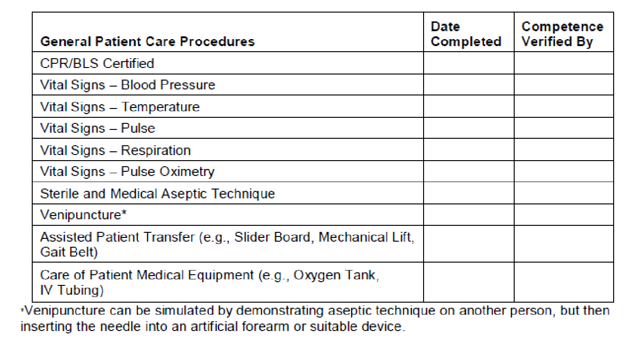

|  |  |  |  |  |  |
| --- | --- | --- | --- | --- | --- |
| **Imaging Procedures** | **Mandatory or Elective** | | **Eligible for**  **Simulation** | **Date Completed** | **Competence Verified By** |
|  | Mandatory | Elective |
| **Chest and Thorax** |  |  |  |  |  |
| Chest Routine | ✓ |  |  |  |  |
| Chest AP (Wheelchair or Stretcher) | ✓ |  |  |  |  |
| Ribs | ✓ |  | ✓ |  |  |
| Chest Lateral Decubitus |  | ✓ | ✓ |  |  |
| Sternum |  | ✓ | ✓ |  |  |
| Upper Airway (Soft-Tissue Neck) |  | ✓ | ✓ |  |  |
| Sternoclavicular Joints |  | ✓ | ✓ |  |  |
| **Upper Extremity** |  |  |  |  |  |
| Thumb or Finger | ✓ |  | ✓ |  |  |
| Hand | ✓ |  |  |  |  |
| Wrist | ✓ |  |  |  |  |
| Forearm | ✓ |  |  |  |  |
| Elbow | ✓ |  |  |  |  |
| Humerus | ✓ |  | ✓ |  |  |
| Shoulder | ✓ |  |  |  |  |
| Clavicle | ✓ |  | ✓ |  |  |
| Scapula |  | ✓ | ✓ |  |  |
| AC Joints |  | ✓ | ✓ |  |  |
| ***Trauma:*** Shoulder or Humerus  (Scapular Y, Transthoracic or Axial)* | ✓ |  |  |  |  |
| ***Trauma:*** Upper Extremity (Non-Shoulder)* | ✓ |  |  |  |  |
| **Lower Extremity** |  |  |  |  |  |
| Toes |  | ✓ | ✓ |  |  |
| Foot | ✓ |  |  |  |  |
| Ankle | ✓ |  |  |  |  |
| Knee | ✓ |  |  |  |  |
| Tibia-Fibula | ✓ |  | ✓ |  |  |
| Femur | ✓ |  | ✓ |  |  |
| Patella |  | ✓ | ✓ |  |  |
| Calcaneus |  | ✓ | ✓ |  |  |
| ***Trauma:*** Lower Extremity* | ✓ |  |  |  |  |

* Trauma requires modifications in positioning due to injury with monitoring of the patient’s condition.

|  |  |  |  |  |  |
| --- | --- | --- | --- | --- | --- |
| **Imaging Procedures** | **Mandatory or Elective** | | **Eligible for**  **Simulation** | **Date Completed** | **Competence Verified By** |
|  | **Mandatory** | **Elective** |
| **Head** – Candidates must select at least one elective procedure from this section. |  |  |  |  |  |
| Skull |  | ✓ | ✓ |  |  |
| Facial Bones |  | ✓ | ✓ |  |  |
| Mandible |  | ✓ | ✓ |  |  |
| Temporomandibular Joints |  | ✓ | ✓ |  |  |
| Nasal Bones |  | ✓ | ✓ |  |  |
| Orbits |  | ✓ | ✓ |  |  |
| Paranasal Sinuses |  | ✓ | ✓ |  |  |
| **Spine and Pelvis** |  |  |  |  |  |
| Cervical Spine | ✓ |  |  |  |  |
| Thoracic Spine | ✓ |  | ✓ |  |  |
| Lumbar Spine | ✓ |  |  |  |  |
| Cross-Table (Horizontal Beam)  Lateral Spine (Patient Recumbent) | ✓ |  | ✓ |  |  |
| Pelvis | ✓ |  |  |  |  |
| Hip | ✓ |  |  |  |  |
| Cross-Table (Horizontal Beam)  Lateral Hip (Patient Recumbent) | ✓ |  | ✓ |  |  |
| Sacrum and/or Coccyx |  | ✓ | ✓ |  |  |
| Scoliosis Series |  | ✓ | ✓ |  |  |
| Sacroiliac Joints |  | ✓ | ✓ |  |  |
| **Abdomen** |  |  |  |  |  |
| Abdomen Supine | ✓ |  |  |  |  |
| Abdomen Upright | ✓ |  | ✓ |  |  |
| Abdomen Decubitus |  | ✓ | ✓ |  |  |
| Intravenous Urography |  | ✓ |  |  |  |

|  |  |  |  |  |  |
| --- | --- | --- | --- | --- | --- |
| **Imaging Procedures** | **Mandatory or Elective** | | **Eligible for Simulation** | **Date Completed** | **Competence Verified By** |
|  | **Mandatory** | **Elective** |
| **Fluoroscopy Studies** – Candidates must select two procedures from this section and perform per site protocol. *ONE must be either UGI OR Contrast Enema. |  |  |  |  |  |
| Upper GI Series, Single or Double Contrast | ✓* |  |  |  |  |
| Contrast Enema, Single or Double Contrast | ✓* |  |  |  |  |
| Small Bowel Series |  | ✓ |  |  |  |
| Esophagus (*NOT* Swallowing Dysfunction Study/Modified BA Swallow) |  | ✓ |  |  |  |
| Cystography/Cystourethrography |  | ✓ |  |  |  |
| ERCP |  | ✓ |  |  |  |
| Myelography |  | ✓ |  |  |  |
| Arthrography |  | ✓ |  |  |  |
| Hysterosalpingography |  | ✓ |  |  |  |
| **Mobile C-Arm Studies** |  |  |  |  |  |
| C-Arm Procedure (Requiring Manipulation to Obtain More Than One Projection) | ✓ |  | ✓ |  |  |
| Surgical C-Arm Procedure (Requiring Manipulation Around a Sterile Field) | ✓ |  | ✓ |  |  |
| **Mobile Radiographic Studies** |  |  |  |  |  |
| Chest | ✓ |  |  |  |  |
| Abdomen | ✓ |  |  |  |  |
| Upper or Lower Extremity | ✓ |  |  |  |  |
| **Pediatric Patient** (Age 6 or Younger) |  |  |  |  |  |
| Chest Routine | ✓ |  | ✓ |  |  |
| Upper or Lower Extremity |  | ✓ | ✓ |  |  |
| Abdomen |  | ✓ | ✓ |  |  |
| Mobile Study |  | ✓ | ✓ |  |  |
| **Geriatric Patient** (At Least 65 Years Old **and** Physically or Cognitively Impaired as a Result of Aging) |  |  |  |  |  |
| Chest Routine | ✓ |  |  |  |  |
| Upper or Lower Extremity | ✓ |  |  |  |  |
| Hip or Spine |  | ✓ |  |  |  |
| **Subtotal** |  |  |  |  |  |
| Total Mandatory exams required | 37 |  |  |  |  |
| Total Elective exams required |  | 15 |  |  |  |
| Total number simulations allowed |  |  | 10 |  |  |

|  |  |  |  |  |  |  |
| --- | --- | --- | --- | --- | --- | --- |
|  |  | **Radiology Examination Log** | | |  |  |
| Students Name: ____________________________ Clinical Ed: I, II, III, IV, V | | | | |  |  |
|  |  |  |  |  |  |  |
| Clinical Site: _______________________ | | |  |  |  |  |
|  |  |  |  |  |  |  |
| Date | Time | Exam Type | Observe Perform, | Tech | # of Repeats | Total # Exams |
|  |  |  | Comp. | initials |  | for Day |
|  |  |  |  |  |  |  |
|  |  |  |  |  |  |  |
|  |  |  |  |  |  |  |
|  |  |  |  |  |  |  |
|  |  |  |  |  |  |  |
|  |  |  |  |  |  |  |
|  |  |  |  |  |  |  |
|  |  |  |  |  |  |  |
|  |  |  |  |  |  |  |
|  |  |  |  |  |  |  |
|  |  |  |  |  |  |  |
|  |  |  |  |  |  |  |
|  |  |  |  |  |  |  |
|  |  |  |  |  |  |  |
|  |  |  |  |  |  |  |
|  |  |  |  |  |  |  |
|  |  |  |  |  |  |  |
|  |  |  |  |  |  |  |
|  |  |  |  |  |  |  |
|  |  |  |  |  |  |  |
|  |  |  |  |  |  |  |
|  |  |  |  |  |  |  |
|  |  |  |  |  |  |  |
|  |  |  |  |  |  |  |
|  |  |  |  |  |  |  |
|  |  |  |  |  |  |  |
|  |  |  |  |  |  |  |
|  |  |  |  |  |  |  |
|  |  |  |  |  |  |  |
|  |  |  |  |  |  |  |
|  |  |  |  |  |  |  |
|  |  |  |  |  |  |  |